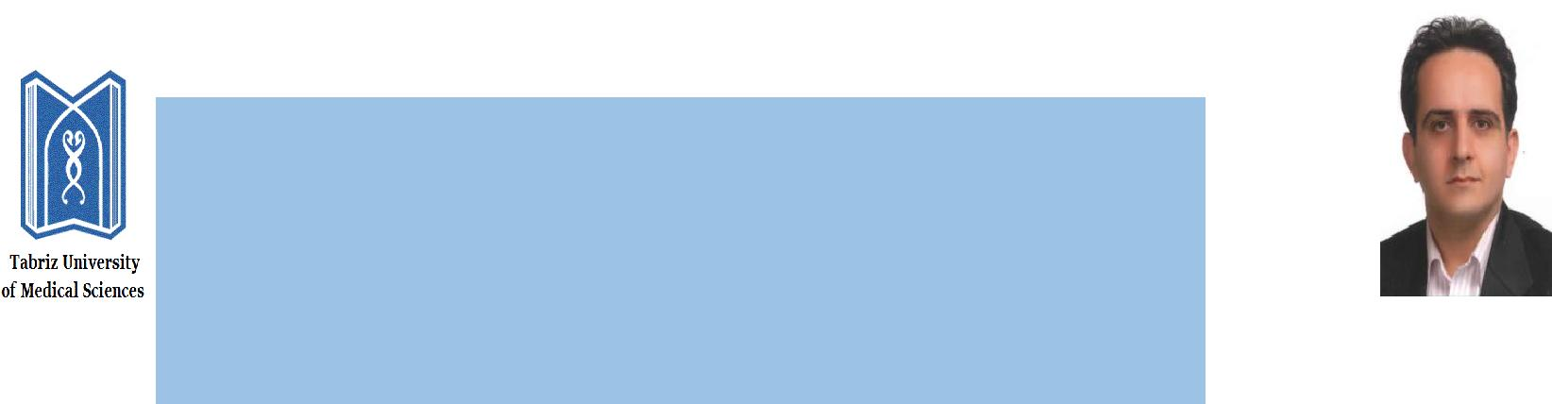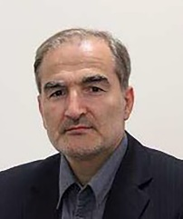

**Curriculum Vitae**

* Personal History

Name: **Ahmad Kousha**

Sex: **Male**

Date of birth: **1960**

Marital Status**: Married**

Number of children**: 2**

Citizenship**: Iran**

Address (Office**): Tabriz / Iran**

Phone (Office):**0098-041-33340309**

Email Address**: koushaa@tbzmed.ac.ir** [**amkousha@hotmail.com**](mailto:amkousha@hotmail.com)

*h* –Index (Scopus): **13**

**Google Scholar:** H index: 22

https://scholar.google.com/citations?user=DuYqoGEAAAAJ&hl=en

* Educational History

|  |  |  |  |  |  |  |
| --- | --- | --- | --- | --- | --- | --- |
| Major | Degree | University | City | Country | Year | |
| From | To |
| General practitioner | MD | Tabriz university of medical sciences | Tabriz | Iran | 1985 | 1992 |
| Infectious and tropical disease | specialty | Tabriz university of medical sciences | Tabriz | Iran | 1995 | 1999 |

* Academic Rank

Professor. 2020 - Ongoing

Associate Professor. 2009-2020

Assistant Professor 2004-2009

Executive Positions and appointments

* Dean of Department of Health Education and Promotion. 2022-Ongoing
* Director of wound committee at Tabriz University of medical Sciences. 2021-ongoing.
* Director of National Public Health Management center (NPMC). Tabriz University of medical Sciences. 2018-2022.
* General Director Center for non-communicable disease prevention &control. Iranian ministry of health. 2015-2017.
* Technical deputy of undersecretary for health. Iranian ministry of health. 2014-2017.
* Public health vice chancellor. Director of Provincial Health Center. Tabriz University of medical Sciences. 2004-2014.
* Head of East Azerbaijan Center for Disease Control. Tabriz University of medical Sciences. 2003-2004.
* Expert of HIV/AIDS, STI, Tuberculosis & Viral hepatitis in provincial health center. Tabriz University of medical Sciences. 1999-2003.

**Foreign languages skills**

* English (fluent in speaking, reading and writing).
* **Attending in seminars, workshops, etc.**

HARVARD Flagship course on health sector reform and sustainable financing, Tehran, 2004

WHO Second generation surveillance, HIV, Cairo, 2004

MDF Health care management, Ede/Amsterdam, 2006

WHO NCD Seminar in Lausanne/Geneva, 2014

WHO cancer Screening and monitoring Workshop, 2017, Ankara

OXFORD Workshop on Implementation Research for Non-communicable Disease Prevention, Oxford, 2017

* **Fields of interest:**
* Preventing and controlling of the diseases
* Health policy
* Public education
* Wound care and wound infection management
* Management education